INDEX

PURPOSE 1
FIRST LEVEL TITLE 1
SECOND LEVEL TITLE 1

Only for large documents, its generated automatically using letter stiles

PURPOSE

The purpose of this document is to provide clear instructions on how to add or remove members from distribution lists within an Active Directory (AD) environment. It aims to guide users through the necessary steps to manage distribution list memberships effectively.

CONTEXT

This document applies to users operating within an Active Directory (AD) environment who need to manage distribution lists. It includes detailed steps for adding or removing members and viewing the owner of the distribution lists. The instructions are intended for internal use and are relevant to users responsible for managing email and internet distribution lists. The document is part of the knowledge base (KB) with the identifier KB0012614 and is active and written in English

Applies to:
Environment: AD.
How to add / remove members from Distribution Lists
Open Panel control and select “Windows Tools”
Click on “Network” (1) and “search Active Directory” (2)
Type the email of the distribution list and click in “FIND NOW”
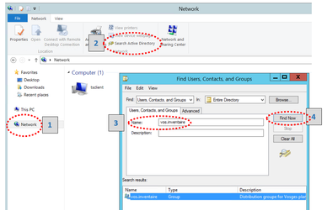
You will be able to see the members and the buttons “add” or “remove”
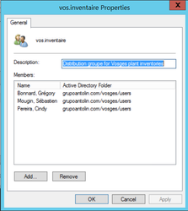
Only the owner of the distribution list can add or remove members.

How to view the Owner of the Distribution Lists
Find the distribution list (as we showed you before) and click in:
View choose Columns…
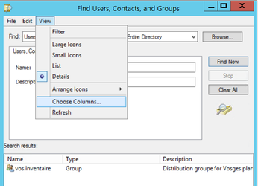
You need to select “Managed by” and click in the button “add >>”.
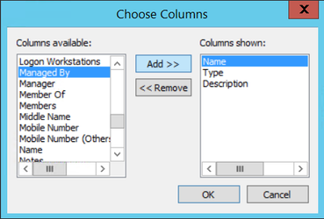

Now a new column will be showed with the owner of the distribution list, contact the owner in order to add or remove members.

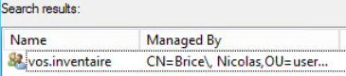
Only for internal use
Short Description | How to add / remove members from Distribution Lists
KB Group | Email & Internet
KB Owner | User Workplace & Databases
Meta | distribution lists, add users distribution lists, modify users distribution lists
Target Readers | Users
Language | English
Active | Yes
KB Number | KB0012614

